

Politecnico di Milano

A.Y. 2017/2018

Software Engineering 2: ***Travlendar+***

**Design Document**

Matteo Biasielli - Emilio Capo - Mattia Di Fatta

v. 0.1

**Table of Contents**

**1. Introduction**

1.1. Document purpose..………………………………………………...………………….3

1.2. Definitions, Acronyms, Abbreviations………………………………………….3

1.2.1 Definitions……………………………………………………………………….3

1.2.2 Acronyms………………………………………………………………………..3

1.2.3 Abbreviations…………………………………………………………………..3

1.3. Reference Documents…………………………………………………………………4

1.4. Document Structure……………………………………………………………………5

1.5. Revision History…………………………………………………………………………5

**2. Architectural Design**

**3. Algorithm Design**

**4. User Interface Design**

4.1 Additional UIs

4.2 Mapping UIs into Requirements

**5. Requirements Traceability**

**6. Implementation, integration and test plan**

**7. Effort Spent**

**1. Introduction**

* 1. **Document purpose**

This document has to be intended as a general guide for the correct development of the Travlendar+ application. The content of this document follows and is based on the content of the RASD document. This document is meant to be a reference for any person who has an interest in the project. This includes, but is not limited to, development team members, stakeholders and end users.

* 1. **Definitions, Acronyms, Abbreviations**
     1. **Definitions**
* **User**: actor that is using the application and may want to access all functionalities.
* **Application**: with the term application we are talking about the desktop version, the website and mobile version of the Travlendar+ system.
* **Scheduling**: action performed by a user that is adding a new activity to his personal calendar.
* **Flexible Activity**: An activity with starting and ending time larger than the duration.
* **Fixed Activity**: An activity with fixed starting and ending time.
  + 1. **Acronyms**
* **RASD:** Requirements Analysis and Specification Document
* **DD:** Design Document
* **UI:** User Interface
* **API:** [Application programming interface](https://en.wikipedia.org/wiki/Application_programming_interface)
* **UXD**: User Experience Diagram
* **UML**: Unified Modeling Language
* **GPS**: Global Positioning System
  + 1. **Abbreviations**
* **[Gn]:** the n-th goal
* **[Rn]:** the n-th requirement
* **[NFRn]:** the n-th non-functional requirement
* **[An]:** the n-th assumption
* **[Cn]:** the n-th constraint
* **[UIn**]: the n-th user interface example
  1. **Reference Documents**
* Mandatory project assignments for the A.Y. 2017/2018 available on the beep’s page of the Software Engineering 2 course.
* Projects examples and other documents available on the beep’s page of the Software Engineering 2 course.
  1. **Document Structure**
* **Introduction:** This is the very first part of the document.

In this section it’s possible to retrieve general information about the Design Document. The purpose and intended audience of the document are specified here.

In addition, Acronyms, Definitions and Abbreviations are defined in this section in order to make it easier, more concise and clearer to read the rest of the Design Document.

* **Architectural Design:** This part represents the second chapter of the document. Here the reader can find the architecture of the system components at various levels and contexts.

First of all, a high-level overview of the components and the way they’re connected is provided in this section. Following this, some components will be analysed in detail and their internal architectures will be showed for a matter of clarity.

* **Algorithm Design:** The most important algorithms that will be implemented in our application are described here, both with natural language and with java code/pseudocode.
* **User Interface Design:** Some User Interface samples have already been provided in the RASD document but they’ll be extended and some will be added in this section of the Design Document.

In addition, further explanation about the already existing UI will be added here, together with a detailed mapping of the User Interfaces into functional requirements and non-functional requirements.

* **Requirements Traceability:** Design choices are mapped into functional and non-functional requirements here.
  1. **Revision History**
* **v. 0.1 [28 Oct 2017]**: added the whole “Introduction” section.

**4. User Interface Design**

**4.1 Additional UIs**

Though some UI samples have already been provided in the RASD document ( see from [UI1] to [UI8] in RASD), for a better mapping of our design choices into the requirements another one is provided in the DD document.

**[UI9]**

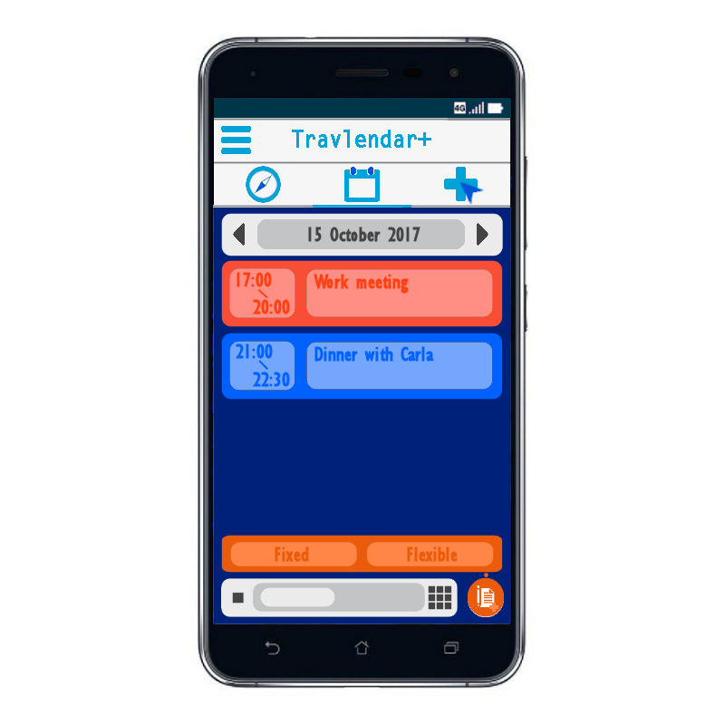

This UI shows how users can differentiate between fixed and flexible activities. This is obtained through a small menu that pops up after tapping on the Create New Activity button.**4.2** **Mapping UIs into Requirements**

Considering the functional requirements, that have already been described in detail in the RASD document, here’s a brief explanation of how our User Interface samples are coherent with the requirements and help us to satisfy them in order to reach the defined goals ( -> RASD ):

* + - [UI4] (and [UI9]) show the day’s activities. By tapping on them it’s possible to reach the screen from which it’s possible to modify an activity. They match with [R1];
    - [UI1], the login screen, matches with [R2]. Furthermore, it also matches with [R3] and [R4] because it shows it’s possible to change password and to register in the system as a new user;
    - [UI8] and [UI9] match with [R5] because they show it’s possible to create fixed and flexible activities;
    - [UI2] satisfies [R6], [R6.1] and [R9] because it shows some of the possible preferences, including the possibility to take into consideration bike and car sharing;
    - [UI6] and [UI7] obviously match with [R11] because they show mobility options and travelling phase;

**7. Effort Spent**

This section will provide detailed information about the number of hours spent on this document.

**Matteo Biasielli**, matr. 893590

|  |  |
| --- | --- |
| **Section(s)** | **Number of hours** |
| 28-oct-17 Introduction | 1 |
|  |  |
|  |  |
|  |  |
|  |  |
|  |  |
|  |  |
|  |  |
|  |  |
|  |  |
|  |  |
|  |  |
|  |  |
|  |  |
|  |  |
|  |  |
|  |  |
|  |  |
|  |  |
|  |  |
| **TOTAL:** |  |

**Mattia Di Fatta,** matr. 893608

|  |  |
| --- | --- |
|  |  |
|  |  |
|  |  |
|  |  |
|  |  |
|  |  |
|  |  |
|  |  |
|  |  |
|  |  |
|  |  |
|  |  |
|  |  |
|  |  |
| **TOTAL:** |  |

**Emilio Capo,** matr. 899842

|  |  |
| --- | --- |
|  |  |
|  |  |
|  |  |
|  |  |
|  |  |
|  |  |
|  |  |
|  |  |
|  |  |
|  |  |
|  |  |
|  |  |
|  |  |
|  |  |
|  |  |
| **TOTAL:** |  |